1. If coming from Elmira, take highway 86 and turn right onto Covered Bridge Road.
2. If coming from Waterloo, take Northfield Drive North for 8.8 km from RIM/Univeristy . Turn right onto highway 86 – 2.2 km. Turn right onto Covered Bridge Road – 800 m.

This map is from our rehearsal hall to West Montrose.

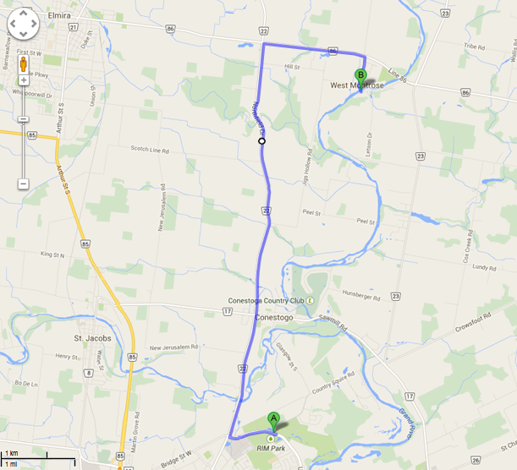

If coming from Kitchener or Cambridge, take the expressway to Univerisity Ave East. Drive along Univerisity and turn right onto Northfield Drive – 8.8 km. Turn right onto highway 86 – 2.2 km. Turn right onto Covered Bridge Road 800 m.

