Grand Harmony Chorus
  - Volume 1 / Issue 1
Change is inevitable in life. You can either resist it and potentially get run over by it, or you can choose to cooperate with it, adapt to it, and learn how to benefit from it. When you embrace change you will begin to see it as an opportunity for growth. Jack Canfield
Grand Harmony Chorus had an Inspiring 2020 Year!
Change is inevitable in life. You can either resist it and potentially get run over by it, or you can choose to cooperate with it, adapt to it, and learn how to benefit from it. When you embrace change you will begin to see it as an opportunity for growth. Jack Canfield
How Grand Harmony Chorus was Formed
A group of women from the K-W four-part harmony chorus wanted something different, so they took the leap and formed a new ensemble. The original people that started this was Diana Ceccato and the late Judy Ketchen, Peggy Senior, Sharon Beard, Jackie Stewart and Sherry Helmka. The group would practice in Sherry Helmka’s living room. They did not have a bass, so they would use a four-part recording from Sweet Adeline’s International. Each of the members took on many executive roles for awhile until more women joined the chorus and they became hooked with the barbershop style of music. There was much discussion on the what the name should be for the chorus and the founding members decided it should be duly noted as Grand Harmony. Grand Harmony Chorus chartered in March 1995. We have over 40 members in our chorus and it has and it continues to be a fabulous harmonious journey for everyone.
Grand Harmony Chorus navigated its way through an interesting 2020 year, we took on many challenges, firstly having zoom rehearsals. Our Management, Music and Performance Teams brainstormed and came up with positive and wonderful ideas for skill development for our zoom rehearsals.
We enjoyed learning opportunities from international and local coaches, learned new warmups, made a Christmas Music Video and had an Online Silent Auction. A special thank you to our Christmas Show, Management, Music teams and members for participating in this new way of learning, singing and performing. We donated a portion of our monies raised from the auction to a local charity, Women's Crisis Services of Waterloo Region which were very appreciative.
December, normally is usually quite busy with performances, as in previous years. This year, we were fortunate to have some outings, which our members embraced, they had a new twist to them, “Masked & Distanced Parking Lot Sing Outs”. We sang at Trillium Lutheran Church in Kitchener on Dec 6th, our MC was Claudia Stewart and organized by Dianne Ritz, Treasurer and Carrie Debrone, Performance Co Ordinator.
We also enjoyed carolling one beautiful winter evening as we strolled through the beautiful Christmassy decorated neighbourhood at Stonecroft Community Living in New Hamburg on Dec 20th and it ended with a hot apple cider and goodies courtesy of Elaine Lewis. We even had a resident, Mary Beth McCabe, with many notable musical abilities, join us to play the flute for a song at each of our stops. Our members loved getting together at these sing outs, it definitely was too long of time not be together.
Music gives a soul to the universe, wings to the mind, flight to the imagination and life to everything. Plato
There’s a saying, ‘something good is going to happen to you today’.
It is my wish that all of our sister chorus’s in Region 2 and all other regions, and throughout the Sweet Adeline world, will soon return to their place on the risers this year.
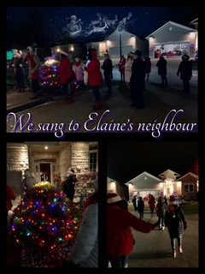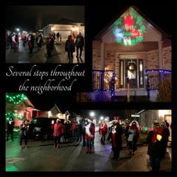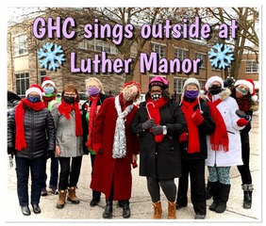

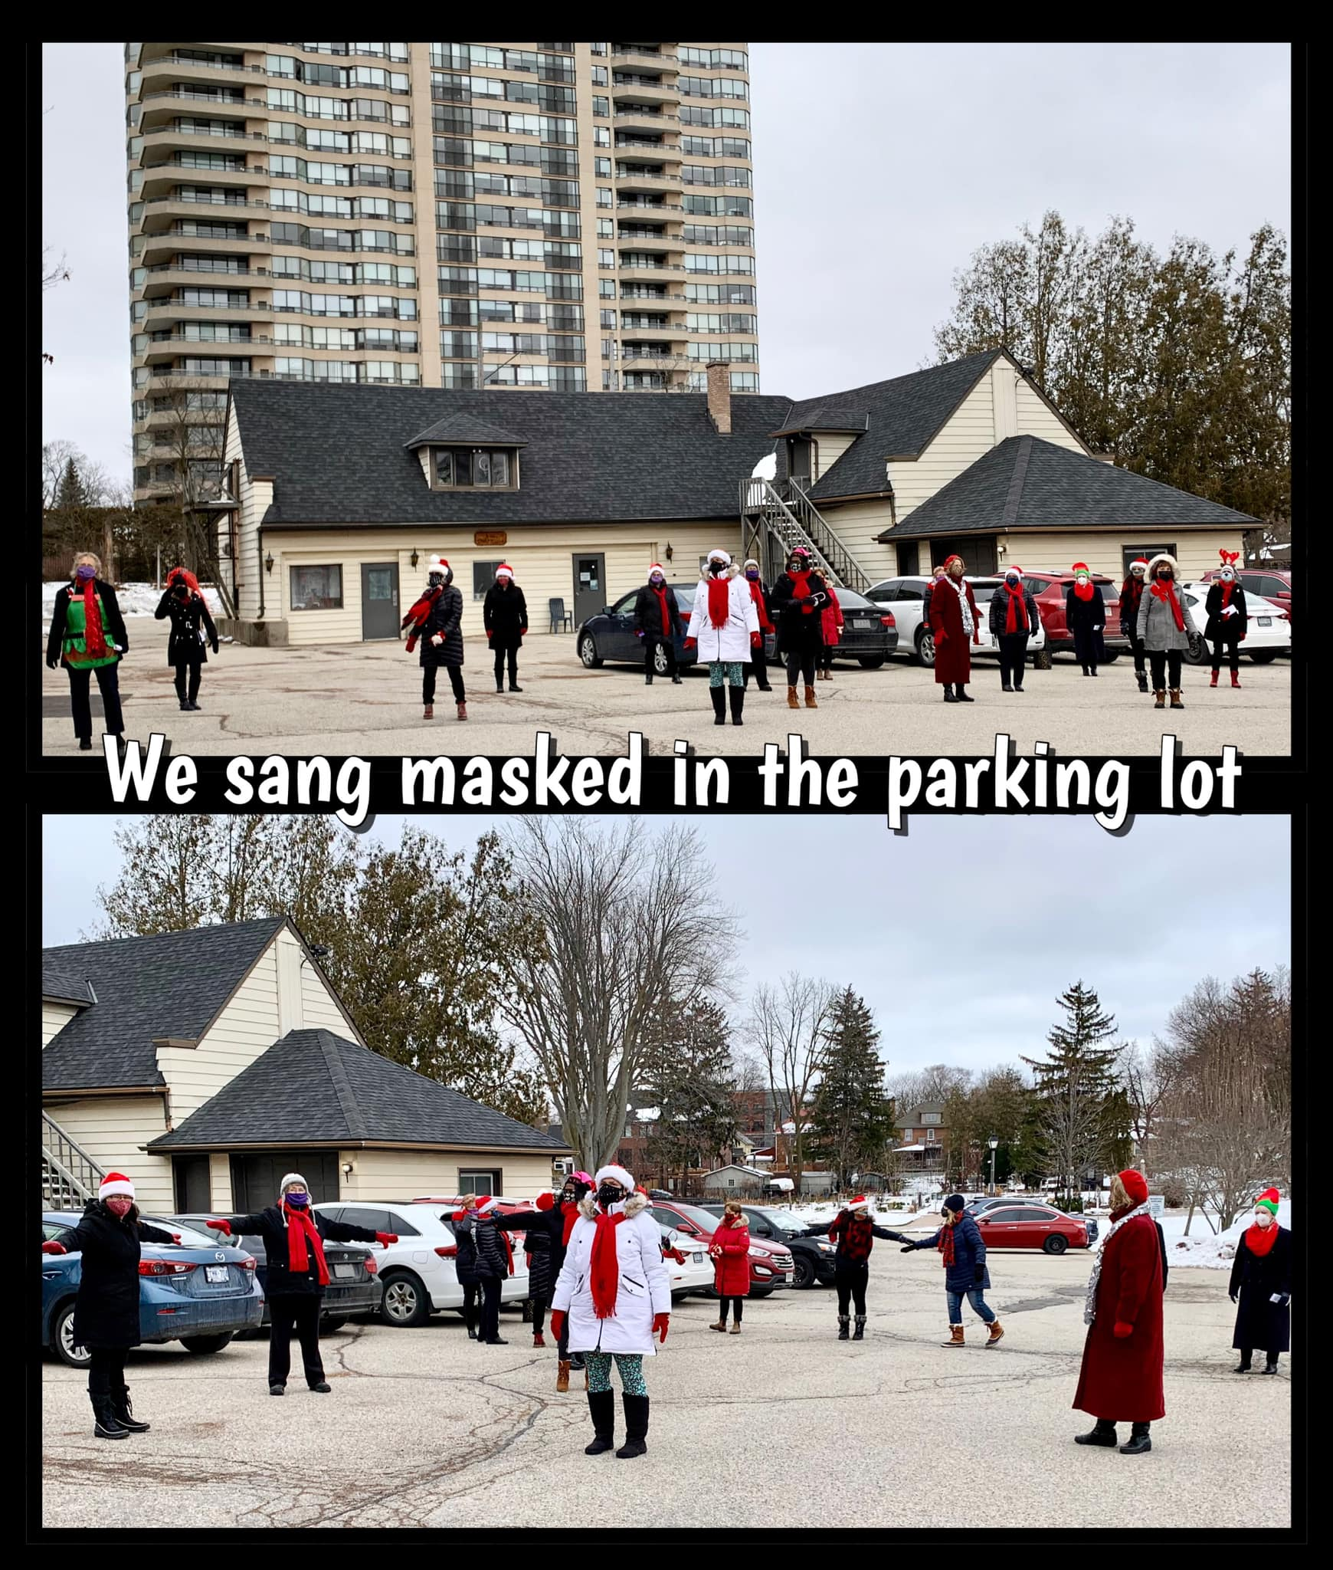
Stonecroft in New Hamburg
December Evening Christmas Carolling

Grand Harmony Chorus
Waterloo, Ontario
www.grandharmonychorus.com
519-291-1656
info@grandharmonyshowchorus.com
